**a. Create a PL/SQL program using cursors, to retrieve first tuple from the department relation.**

**b. (use table dept(dno, dname, loc))**

**Program:**

DECLARE

DDEPTCODE VARCHAR2(4);

DDEPTNAME VARCHAR2(15);

DHOD VARCHAR2(4);

CURSOR cursor1 IS

SELECT DEPTCODE,DEPTNAME,HOD FROM DEPARTMENT;

BEGIN

OPEN cursor1;

FETCH cursor1 INTO DDEPTCODE,DDEPTNAME,DHOD;

DBMS_OUTPUT.PUT_LINE('Department Code= '||DDEPTCODE||' Department Name= '||DDEPTNAME||' Department HOD= '||DHOD);

CLOSE cursor1;

END;

/

**Output:**

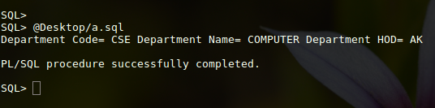

**c. Create a PL/SQL program using cursors, to retrieve each tuple from the department relation.**

**d. (use table dept(dno, dname, loc))**

**Program:**

DECLARE

DDEPTCODE VARCHAR2(4);

DDEPTNAME VARCHAR2(15);

DHOD VARCHAR2(4);

rowcount NUMBER;

CURSOR cursor1 IS

SELECT DEPTCODE,DEPTNAME,HOD FROM DEPARTMENT;

BEGIN

OPEN cursor1;

DBMS_OUTPUT.PUT_LINE( '---------- cursor 1-----------------' );

LOOP

FETCH cursor1 INTO DDEPTCODE,DDEPTNAME,DHOD;

EXIT WHEN cursor1%NOTFOUND;

DBMS_OUTPUT.PUT_LINE( RPAD(DDEPTCODE, 25, ' ') || RPAD(DDEPTNAME,25,' ') || DHOD);

END LOOP;

rowcount := cursor1%ROWCOUNT;

DBMS_OUTPUT.PUT_LINE('The number of rows fetched is ' || rowcount );

CLOSE cursor1;

END;

/

**Output:**

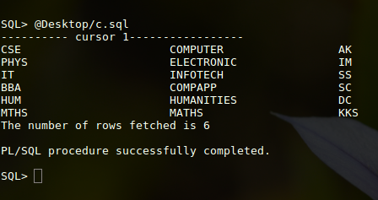

**e. Create a PL/SQL program using cursors, to display the number, name, salary of the three highest paid employees.**

**f. (use table emp(empno, ename,sal))**

**Program:**

set serveroutput on;

DECLARE

FFACULTYCODE VARCHAR2(4);

FFACULTYNAME VARCHAR2(15);

FSALARY NUMBER(8,2);

rowcount NUMBER;

CURSOR cursor1 IS SELECT FACULTYCODE,FACULTYNAME,SALARY FROM (SELECT * FROM faculty ORDER BY SALARY DESC) WHERE rownum<=3 ORDER BY Salary ;

BEGIN

OPEN cursor1; -- open cursor1 before fetching

DBMS_OUTPUT.PUT_LINE( '---------- cursor 1-----------------' );

LOOP

FETCH cursor1 INTO FFACULTYCODE,FFACULTYNAME,FSALARY;

EXIT WHEN cursor1%NOTFOUND;

DBMS_OUTPUT.PUT_LINE( RPAD(FFACULTYCODE, 25, ' ') || RPAD(FFACULTYNAME,25,' ') || FSALARY);

END LOOP;

rowcount := cursor1%ROWCOUNT;

DBMS_OUTPUT.PUT_LINE('The number of rows fetched is ' || rowcount );

CLOSE cursor1;

END;

/

**Output:**

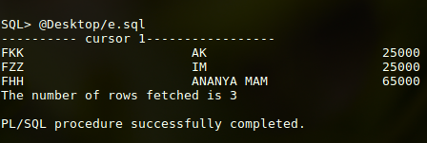

**g. Create a PL/SQL program using cursors, to delete the employees whose salary is more than 3000.**

**Program:**

set serveroutput on;

DECLARE

FFACULTYCODE VARCHAR2(4);

FFACULTYNAME VARCHAR2(15);

FSALARY NUMBER(8,2);

rowcount NUMBER;

CURSOR cursor1 IS select FACULTYCODE,FACULTYNAME,SALARY from faculty;

BEGIN

OPEN cursor1;

DBMS_OUTPUT.PUT_LINE( '---------- cursor 1-----------------' );

LOOP

DELETE FROM FACULTY WHERE SALARY>25000;

FETCH cursor1 INTO FFACULTYCODE,FFACULTYNAME,FSALARY;

EXIT WHEN cursor1%NOTFOUND;

DBMS_OUTPUT.PUT_LINE( RPAD(FFACULTYCODE, 25, ' ') || RPAD(FFACULTYNAME,25,' ') || FSALARY);

END LOOP;

rowcount := cursor1%ROWCOUNT;

DBMS_OUTPUT.PUT_LINE('The number of rows fetched is ' || rowcount );

CLOSE cursor1;

END;

/

**h. Create a PL/SQL program using cursors, to update the salary of each employee by the avg salary if their salary is less than avg salary.**

**Program :**

declare

c_facultycode faculty.facultycode%type;

c_facultyname faculty.facultyname%type;

c_salary faculty.salary%type;

c_avgsalary NUMBER(10);

cursor faculty_list is

select facultycode,facultyname,salary from faculty where salary <(select avg(salary) from faculty);

c Number;

begin

open faculty_list;

select avg(salary) into c_avgsalary from faculty;

loop

fetch faculty_list into c_facultycode, c_facultyname, c_salary;

exit when faculty_list%notfound;

c_salary := c_salary + c_avgsalary;

update faculty set salary = c_salary where facultycode =c_facultycode;

-- dbms_output.put_line(c_facultycode ||' '||c_facultyname||' '||c_salary);

end loop;

close faculty_list;

End;